Best First Search Algorithm
AIM:
To write a Prolog program to implement the Best First Search algorithm for finding a path from a start node to a goal node.

ALGORITHMS:
- Start.
- Define the graph with nodes, edges, and heuristic values.
- Initialize the open list with the start node.
- Initialize the closed list as empty.
- Select the node with the lowest heuristic value from the open list.
- If the selected node is the goal node, display the solution path and stop.
- Otherwise, move the selected node to the closed list.
- Generate its unvisited successor nodes and add them to the open list with their heuristic values.
- Repeat Steps 5–8 until the goal is found or the open list becomes empty.
- If the open list is empty, report that no solution was found.
- Stop.

CODE:
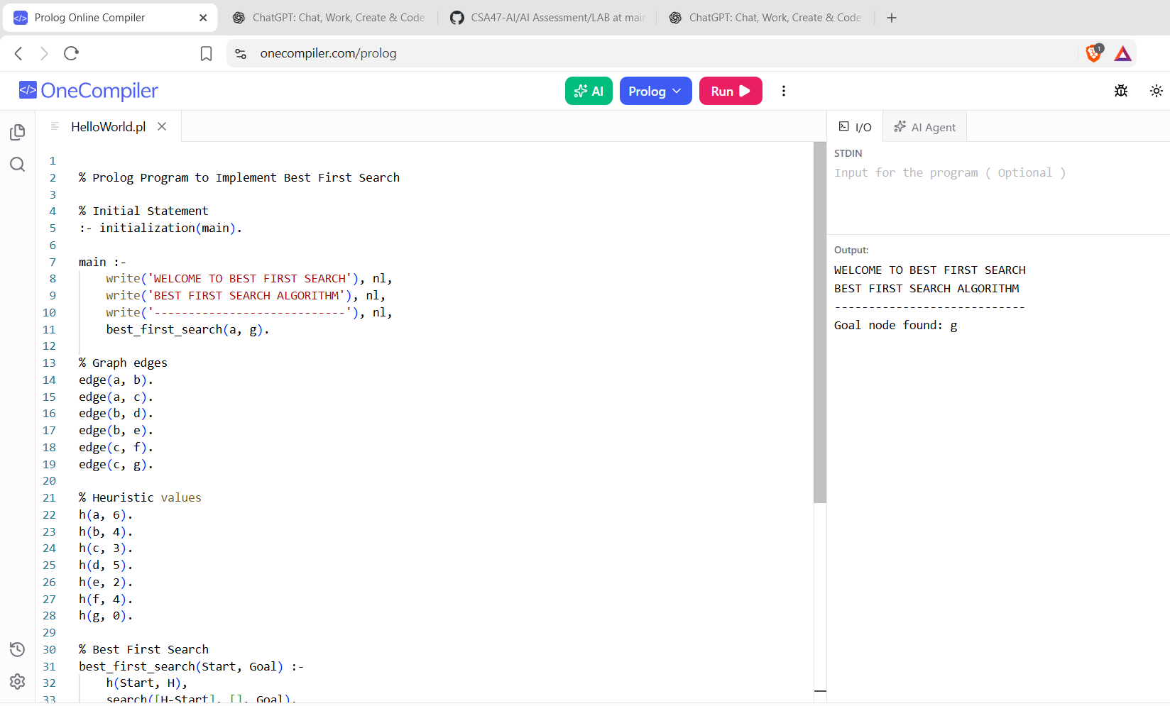

RESULTS:
The program explores the nodes according to their heuristic values and finds a path to the goal, if one exists

